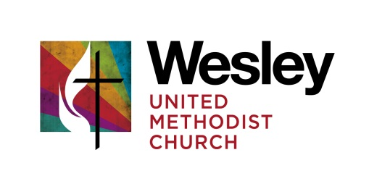
GOVERNING BOARD MEETING
January 8, 2017
Kathy Breazeale | Fred Neuman | Pastor John Bell
Wally Loague | Bruce Lawrie | Bruce Lindgren
Bob McKnight | Roger Curless

Worship & Lighting of the Christ Candle
The Christ candle was lit and opening prayers were offered. For ongoing worship the Methodist Prayer resource from www.methodistprayer.org will be used. This included Words of Praise, scripture from Old and New Testaments and individual prayers for intercession and thanksgiving. This resource will be introduced to the congregation as something the Governing Board is using. It will be a suggested daily guide for meditation.

What Can We Celebrate Since Last We Met

- Review of the minutes from December 12, 2016
The minutes have been placed on the website for congregational review.
What do we need to accomplish in our time together today?
- Annual Church Conference – Sunday, January 20, 2017
Time was spent fitting the work of the Governing Board and church into the outline prepared by the District Superintendent. Roger and Pastor John will complete the agenda. The Governing Board will be involved in preparing and serving the meal.
The meal provisions:
- Soup Wally and Fred to coordinate
- Dessert – Kathy
- Breads and butter – Kathy
- Relish trays and crackers – Roger
- Drinks (other than coffee and water) – Fred
We will plan for 30-40 people and the Governing Board will help serve the meal as needed.
The Governing Board will take some different roles at the Church Conference:
- Words of Welcome – Pastor John
- Greeting and call to order – Superintendent
- Celebrating the Year in Ministry - Reviewing of our first year in single board governance – Roger
- Scripture – Fred
- A time of conferencing with the Superintendent
- Business Presentations
- Endowment Policy, Safe Sanctuaries, Election of Endowment Committee – Trustees
- Clergy Compensation – Staff-Parish
- Grievance Policy – Staff-Parish
- Affirmation of Lay Servants – John
- Election of the Governing Board - John
- Suggestions for Governing Board Nominations
Another individual in the congregation is giving prayerful thought about applying for the Governing Board.

- District Training Event
On January 28th there will be a training event at Naperville Grace UMC on helping churches tell their story. So far Kathy and Pastor John are planning to attend. All are encouraged to participate.
- Our Ministry Areas (Those with current items for the Governing Board)
Discipleship
The six week class on discipleship begins on the 12th. This is the class for all those considering becoming members of Wesley. Governing Board members are encourage to participate along with several families now starting the path.
Outreach
Pastor John will assume the responsibilities as a new coordinator as not been secured.
Worship
Congregational Care
Administration
Through a combination of memorial gifts, funds raised by the Fine Arts Committee and some budget funds it is possible to replace the carpet floor in the Gathering Place. After some discussion of pros and cons on doing it now, it was determined that the project should move forward at this time.
- Our Administrative Areas (Those with current items for the Governing Board)
Finance
The 2017 budget was presented by Pastor John. The budget is projected to be $454,183 with income of $408,180. The full projection on investment income, some of which will be added to the revenue is not known but may not cover the entire shortfall. This will need to be made up with additional revenue above projection and careful management of expenditures. The budget was adopted by the Governing Board.

The audit is still being organized. Bruce Lawrie is coordinating with the auditor. The Governing Board is in agreement that some kind of audit or financial review needs to be done every year.

Trustees
The focus has been getting everything ready for the Church Conference.
Staff Parish Relations Committee
No business

What challenges, obstacles, risks are we facing? What or Who at Wesley needs our prayers today?
- We are still in need of a secretary for the Board.
- We need to elect two lay members of the Annual Conference at the Church Conference. The Annual Conference sessions are much shorter than in the past.

The meeting closed in prayer for members and friends of the Wesley family and for a request that God continue to bless the work of this church.

Next Meeting: February 13 – 2:00 PM at Wesley

