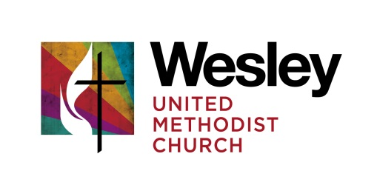
GOVERNING BOARD MEETING
September 11, 2017
Kathy Breazeale | Pastor John Bell | Fred Neuman
Mary Terrell | Wally Loague | Bruce Laurie
Regrets:
Bob McKnight
Bruce Lindgren
Worship & Lighting of the Christ Candle
The Christ candle was lit and opening prayers were offered for members and friends. There was remembrance for 9/11. For ongoing worship the Methodist Prayer resource from www.methodistprayer.org for the day was used. Psalm104 and Mark 4.
What Can We Celebrate Since Last We Met
August minutes were given a final review and have already been posted on the website. Locating the Governing Board minutes on the website is becoming easier with it being place under Forms and Uploads as a special item. The request was made to have the Governing Board area more prominent.
Each Governing Board member is in one of three required areas: Trustees, Finance, Staff-Parish. Newest board member, Mary Terrell will be joining the Trustees.
What do we need to accomplish in our time together today?
Regarding Capital Campaign Process
- The results of the surveys and interviews has been sent to the Governing Board and is available upon request for anyone who attended the meeting or participated in any way.
- A tentative calendar coordinating the stewardship campaign, capital campaign and church conference was reviewed with preliminary action steps to be taken.
- During the late fall, there will be an emphasis on stewardship and a stewardship campaign, however people will not be asked to make a commitment. Instead people will be asked to continue at their current levels of giving until the church conference can be held in early January. Pastor John is working on a date with the presiding elder.
- A Steering Committee needs to be established. The primary functions of the Steering Committee will be:
- Select a theme
- Manage communications about the campaigns
- Play the prayer vigil
- Work with John Laster, the Horizons consultant.
The committee will consistent of two co-chairs, Jenny, the facilities coordinator, Nicole the communications coordinator, two persons to plan the prayer vigil and prayers though out the campaign, two to plan a celebration event and two to form a committee to do follow-up contacts. While members of the Governing may choose to participate it was decided to open participation to the wider congregation. Governing Board members are to get suggested names to Pastor John who will do the invitations. Names should be submitted by September 18th. Members of the Steering Committee should be passionate about Wesley Church, clear on Wesley’s mission and vision, have some active role in the life of the congregation and should be financially committed to the church.
There was discussion on the need to give particular attention to the communications process not only on the campaign but also generally on the work of the Governing Board.
Regarding Capital Campaign Projects
The capital campaign projects have been listed in 15 related areas that are either beautification, maintenance, accessibility or efficiency. The bulk of the meeting consisted of the Governing Board completing an exercise to prioritize these areas. The prioritization by the Board will be shared with other leaders in the congregation for feedback and the possibility of changing the list order somewhat.
Using this list the Trustees of the Governing Board will begin formalizing bids for the work. Pastor John, Wally, Jenny, Mary and Bruce Lindgren will work with the bidding process.
Ministry Area Special Notes:
- Supper Clubs are starting again to help connect people.
- Janene has started making neighborhood visitations. Has already visited with Greenman School, World Relief, People for Childcare and is getting more familiar with our immediate neighborhood.
- The Asset Based Community Development (ABCD) model we are using will be the topic of a conference in Chicago at the end of October. Pastor John will be attending with others interested.
- There was a plan to feature the six special Sunday appeals on one Sunday after a lead up in promoting each of the causes. That did not happen so Wesley will match for each of those Sundays the amount given last year and work on the event for next year. In the meantime, there will be some additional emphasis on the World-Wide Communion Sunday and an offering for UMCOR for hurricane relief.
- Worship – There was a discussion on how there might be more organ music in the first service. Pastor John will talk with Felecia and Molly about the balance between organ and piano.
Administrative Ministry Areas
- Finance – Cash flow has been such this year that there has not been a need to draw out of the endowment. We will receive a quarterly summary at the next Board meeting.
- Trustees – A new gas contract has been signed to lock in the rates for two years.
The meeting closed in prayer.
Next meeting: October 16, 2017 – 2:00 PM

