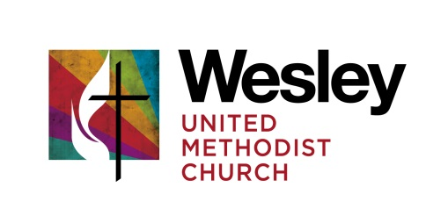
GOVERNING BOARD MEETING
February 19, 2018

Kathy Breazeale Pastor John Bell
Mary Terrell Bruce Lawrie
Roger Curless Bob McKnight

Regrets:
Bruce Lindgren, Fred Neumann, Wally Loague

Worship & Lighting of the Christ Candle
Prayer was shared for the Florida shooting and the response that has been generated by the students, the death of Ted Crawshaw’s brother, neighbor incident that happened in front of church, Barb Lawrie’s nephew. Praise was lifted up for Bill Moore coming home, the announcement of the $190,800 advance gifts for our Capital Campaign and the city approval of the Pride Parade on June 17, 2018.

What Can We Celebrate Since Last We Met
Capital Campaign – Congregational meetings went very well. 16 families comprising 11 couples and 5 individuals gave $190,800.00. This process could serve as a template for further smaller campaigns needed in the future. Commitment Sunday is February 25, 2018.

What do we need to accomplish in our time together today?
Long Range Planning Retreat – for strategic planning will be held Friday, March 16, 2018 from 8:30 am to 4:00 pm. That date is open at the Aurora Public Library. No openings were found on the LaSalle Manor website. Kathy will handle food and have it delivered. What we home to accomplish is a process to plan strategy and how to work from that strategy, rather than being hijacked by the everyday nuts & bolts workings. Hopefully we can set the agenda for the year.
March 12 Brunch with the Governing Board @ 10:00 am. Assignments: Kathy – egg casserole, Marty – fruit, Roger – will make coffee and bring fruit, Bob – roll/bagels. John will publicize.
The next Board conversation with the congregation will be dessert, June 6@ 7pm.

Updates
Finance – we will need to find a new church treasurer, Ruth Velez has resigned. The position does not require a detailed accounting background. It consists of managing check signing, working with Jenny and John, looking over Journal Entries and reports. The use of QuickBooks has made this much easier. Some of this could be done electronically, with small amount of time spent in the office.
Trustees - Changes of signatures will be needed on the Franklin Templeton account. A motion was made by Bob McKnight and seconded by Mary Terrell to change our signers to Walter Loague and Bruce Lawrie. The motion carried unanimously. Also, John felt we could move ahead with the process and hiring of a firm to begin asbestos removal in all of the building, beginning with the removal in the boiler room.
Staff Parish – a discussion was held concerning the changes and vacancies of the coordinator positions. John said he didn’t see need help at this time. Even though Carol Stoffel in out of town, she stays engaged with the process and has very active Team. Meredith is engaged in the Worship planning, John picks up scheduling and some administration. Felicia has been very active in the actual service coordination. It would be nice to have a Liturgical Shepherd, one for each season, to help with details connected with each season. Could we put this out to the congregation to see if there are persons interested in doing this?

Ministry Areas
Outreach – Change the World coming up. A discussion was held on the education of congregation and dissemination of information about the 6 Special Sunday offering for this year – The envelopes for UMCOR will go in March bulletins. The other 5 will be grouped together and home gathering informational meetings will be held and then the appeals will happen in September.
Discipleship – Wendy’s last official day is March 4. She has asked to stay on for Sunday School and Confirmation till the end of the school year. The job description has been sent out to the NIC and other agencies and groups. There is a group planning a Celebration event for Wendy. John would like to have the Staff Parish members and individuals from Children & Family ministries be involved in the interview process for this position.
Budget – will be presented at next meeting.
Fine Arts – Josh Reynolds presented his photographs and the Living Last Supper will be presented again.
Harry Potter Festival – June 9, 2018 – we will offer a character breakfast early the day of the festival – a very popular City event, by turning the Gathering Place into Hogwarts, taking pictures and charge admission. Volunteers will be needed.
Worship – Lenten Series – Listening to God’s voice.

The meeting closed in prayer.

NEXT MEETING: April 11 @ 2:00

